Programming Fundamentals – Lab 04
Rao ALISHA ZAHID
25K-6033
BCE-2A

Task 1: Sports Team Selection Eligibility
Scenario
A college selects students for the annual sports tournament only if their practice attendance is 75% or above.
Requirements
- Input: practice attendance percentage
- Attendance ≥ 75 → Selected for Tournament
- Else → Not Selected
CODE:
#include<stdio.h>
int main(){
int attendence;
printf("enter practice attendence percentage");
scanf("%f",&attendence);
if (attendence >=75){
printf("selected for tournament");
}
else{
printf("not selected");
}
return 0;
}
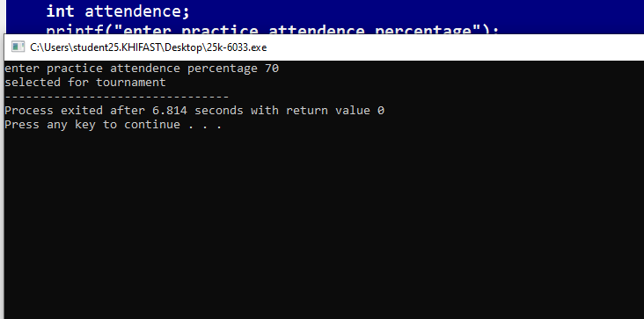

Task 2: Internet Data Usage Category
Scenario
An internet service provider categorizes users based on monthly data consumption.
Requirements
- Input: total GB used
- Conditions:
  - Data ≤ 50 GB → Basic User
  - Data 51–150 GB → Standard User
  - Data > 150 GB → Heavy User
Concept Used
if – else if – else
CODE:
#include<stdio.h>
int main(){
int data;
printf("enter total data used in GB");
scanf("%d", &data);
if(data<=50){
printf("basic user");
}
else if(data>50&&data<=50){
printf("standard user");
}
else{
printf("heavy user");
}
return 0;
}
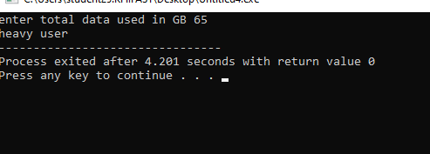

Task 3: Bank Account Balance Status
Scenario
A banking system determines the status of a user’s account balance.
Requirements
- Input: account balance (integer)
- Balance > 0 → Positive Balance
- Balance < 0 → Overdrawn
- Balance = 0 → Zero Balance
Concept Used
if – else if – else

CODE:
#include<stdio.h>
int main(){
int balance;
printf("enter account balance");
scanf("%d", &balance);
if(balance>0){
printf("positive balance");
}
else if(balance,0){
printf("overdawn");
}
else{
printf("zero balance");
}
return 0;
}

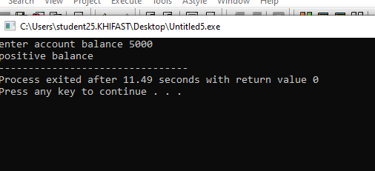

Task 4: Wi-Fi Access Authentication System
Scenario
A secure Wi-Fi network grants access only if correct login credentials are entered.
Requirements
- Predefined credentials:
  - Username: user
  - Password: 7890
- Input: username and password
- If both match → Connected Successfully
- Else → Connection Failed
Concept Used
Logical operators (&&) with if – else
CODE:
#include<stdio.h>

int main(){
char username[10];
int password;

printf("Enter username: ");
scanf("%s", username);

printf("Enter password: ");
scanf("%d", &password);

if(username[0]=='u' && username[1]=='s' && username[2]=='e' && username[3]=='r' && password==7890){

printf("connection successful");
}
else{
printf("connection failed");
}

return 0;
}
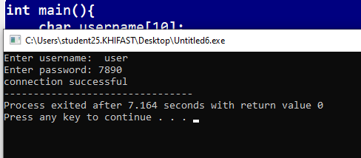

Task 5: Banking Service Menu System
Scenario
A bank provides different services to customers through an ATM system.
Menu
- Balance Inquiry
- Withdraw Money
- Deposit Money
- Exit
Requirements
- Input user choice
- Use switch statement to display relevant message
- Handle invalid choice using default
Concept Used switch statement
Code:
#include <stdio.h>

int main() {
int choice;

printf("ATM Menu \n");
printf("1. Balance Inquiry\n");
printf("2. Withdraw Money\n");
printf("3. Deposit Money\n");
printf("4. Exit\n");
printf("Enter your choice: ");
scanf("%d", &choice);

switch(choice) {
case 1:
printf("You selected Balance Inquiry.");
break;

case 2:
printf("You selected Withdraw Money.");
break;

case 3:
printf("You selected Deposit Money.");
break;

case 4:
printf("Exiting... Thank you for using our ATM.");
break;

default:
printf("Invalid choice. Please select a valid option.");
}

return 0;
}
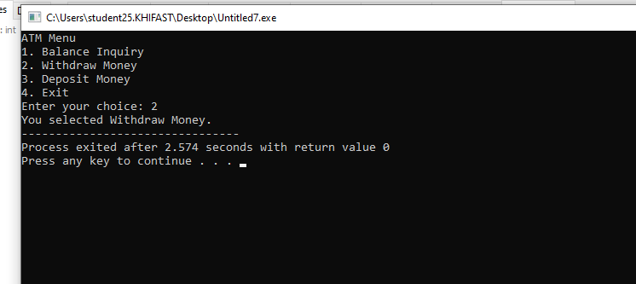

Task 6: Scholarship Evaluation System
Scenario
A university awards scholarships based on marks obtained in five subjects.
Requirements
- Input: Marks (0–100) for any 5 subjects
- Calculate percentage
- Percentage ≥ 85 → Full Scholarship
- Percentage ≥ 70 → Partial Scholarship
- Percentage ≥ 50 → Eligible for Consideration
- Percentage < 50 → Not Eligible
Concept Used
if – else if – else
CODE:
#include<stdio.h>
int main(){
int m1 , m2 , m3, m4 , m5 ;
int total;
float percentage;

printf("Enter marks of 5 subject (0-100)\n");
scanf("%d %d %d %d %d",& m1,&m2,&m3,&m4,&m5);

total = m1 + m2 + m3 + m4 + m5;
percentage = (total / 500.0) * 100;

printf("Percentage: %.2f%%\n", percentage);
if (percentage>=80){
printf("full scolarship\n");
}
else if (percentage >=70){
printf("partial scolarship\n");
}
else if (percentage>=50){
printf("eligible for scolarship\n");
}
else {
printf("not eligible\n");
}
return 0;
}
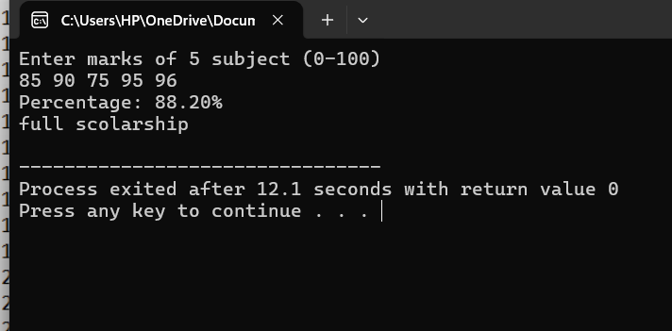

Task 7: Festival Sale Discount Calculator
Scenario
A shopping mall offers discounts during a festival sale based on total purchase amount.
Requirements
- Input: total purchase amount
- ≥ 5000 → 20% discount
- ≥ 3000 → 10% discount
- < 3000 → No discount
Concept Used
if – else if – else

CODE:
#include<stdio.h>
int main(){
float amount , discount , totalamount;

printf("enter purchase amount\n");
scanf("%f",&amount);

if (amount>=5000){
discount = amount * 0.20;
}
else if(amount>=3000){
discount = amount * 0.10;
}
else{
discount = 0;
}
totalamount = amount - discount;

printf("Discount: %.2f\n", discount);
printf("Amount to Pay: %.2f\n", totalamount);

return 0;
}
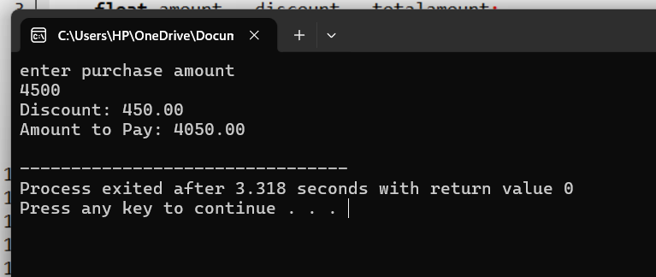

Task 8: Math Operations Console Using Switch
Scenario
A math operations console performs different calculations based on user selection.
Menu
- Addition
- Subtraction
- Multiplication
- Division
- Square of a number
- Cube of a number
- Square Root of a number
- Power (xʸ)
- Absolute Value
- Modulus (Remainder of two numbers)

Requirements
- Display menu
- Input user choice
- Use switch statement

Input Rules
- Options 1–4, 8, and 10 → input two numbers
- Options 5–7 and 9 → input one number

Validations
- Handle division by zero
- Handle square root of negative number
- Handle modulus by zero
- Handle invalid menu choice using default

Concept Used
- switch
- if (validation)
- Relational and logical operators

